QUESTION 3 Notes

Question 3 A
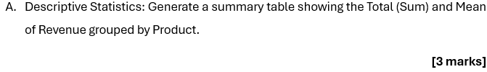
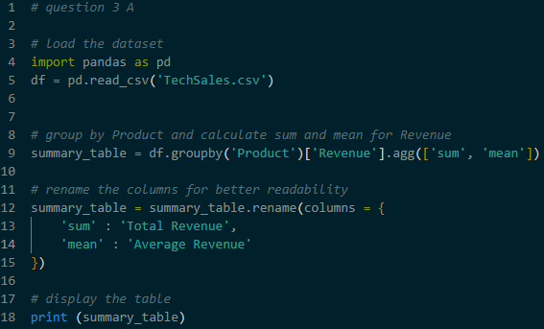
- Action – Using the groupby function on the Product column. Then, use the agg function to calculate the sum(total) and the mean(average) of the Revenue column
- This creates a small table that shows which product brings in the most money overall and which product has the highest average value persale

Question 3 B
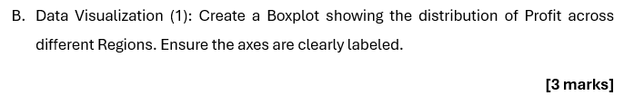
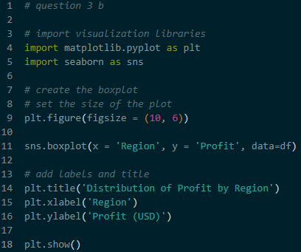
- A boxplot is used to show how numbers are spread out
- Action – Using the boxplot function. Put Region on the horizontal axis (x) and Profit on the vertical axis (y)
- The box shows where the middle 50% of the profits are located. The lines show the highest and lowest profits. This helps identify which regions have steady profits and which have very high or low individual sales

Question 3 C
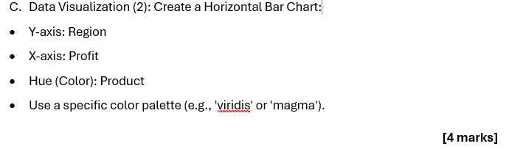
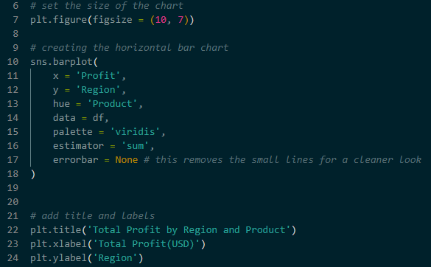
- A horizontal bar chart is useful for comparing multiple categories at the same time
- Action – Using a bar chart where Region is on the vertical axis (y) and Profit is on the horizontal axis (x). Using the hue setting to give each Product a different color
- By putting names on the y-axis, the text is easier to read. Using different color allows to compare the performance of Laptops, Phones, and Tablets within each specific region side-by-side

